
Sandip Foundation’s
Sandip Institute of Engineering and Management,
Mahiravani, Trimbak Road, Nashik-422213

Department of Computer Applications Institute Vision
We at SIEM aspire to be a globally recognized Institute that delivers a world class education to outstanding intellectual by nurturing and grooming by their interest, creative abilities and thrusts to acquire a life-long learning so as to imbibe values of their commitment towards society.

Department Vision
To be a center of excellence in computer applications that nurtures innovation, technical expertise, research aptitude, and ethical values, preparing globally competent professionals with a commitment to lifelong learning, leadership in the digital era, and meaningful contribution to societal and industrial growth.

REPORT
On

“Advanced Excel Workshop”
Name of Event: Advanced Excel Workshop
Date of Event: 27 April 2026
Coordinator of Event: Prof. Alaknanda Pawar, Prof. Prasad Hirey
Name and Details of Resource Person: Osden D’Mello
No of Participants: 58

Introduction
The Department of Computer Applications organized an “Advanced Excel Workshop” for students to enhance their practical knowledge and skills in Microsoft Excel. The workshop was conducted by Mr. Osdon Sir, who guided the participants through various advanced features and applications of Excel used in academics, business analytics, and professional work environments.
The workshop aimed to provide hands-on training and improve students’ efficiency in handling data, creating reports, and performing data analysis using advanced Excel tools.

Objectives of the Workshop
• To introduce students to advanced features of Microsoft Excel.
• To enhance data management and analytical skills.
• To provide practical exposure to formulas, functions, and data visualization techniques.
• To improve students’ productivity in academic and professional tasks.
• To develop problem-solving skills using Excel tools and techniques.

Details of the Workshop
The workshop was conducted in an interactive and practical manner where students actively participated in hands-on exercises. Mr. Osdon Sir explained various advanced Excel concepts with real-time examples and demonstrations.
The following topics were covered during the workshop:
- Advanced formulas and functions
- Logical functions such as IF, AND, OR
- Lookup functions including VLOOKUP and HLOOKUP
- Data sorting and filtering
- Conditional formatting
- Pivot Tables and Pivot Charts
- Data validation techniques
- Dashboard creation and data visualization
- Shortcuts and productivity tips in Excel
Students were encouraged to practice the exercises during the session, which helped them understand the concepts more effectively.

Highlights of the Workshop
- Interactive hands-on training sessions.
- Real-time problem-solving activities.
- Demonstration of industry-oriented Excel applications.
- Practical examples for data analysis and report preparation.
- Active participation and engagement of students.

Outcome of the Workshop
The workshop helped students gain practical knowledge of advanced Excel tools and techniques. Participants developed confidence in handling spreadsheets, performing calculations, creating reports, and analyzing data efficiently.
The session enhanced students’ understanding of Excel applications in business, academics, and professional environments. Students appreciated the workshop for its practical approach and useful learning experience.

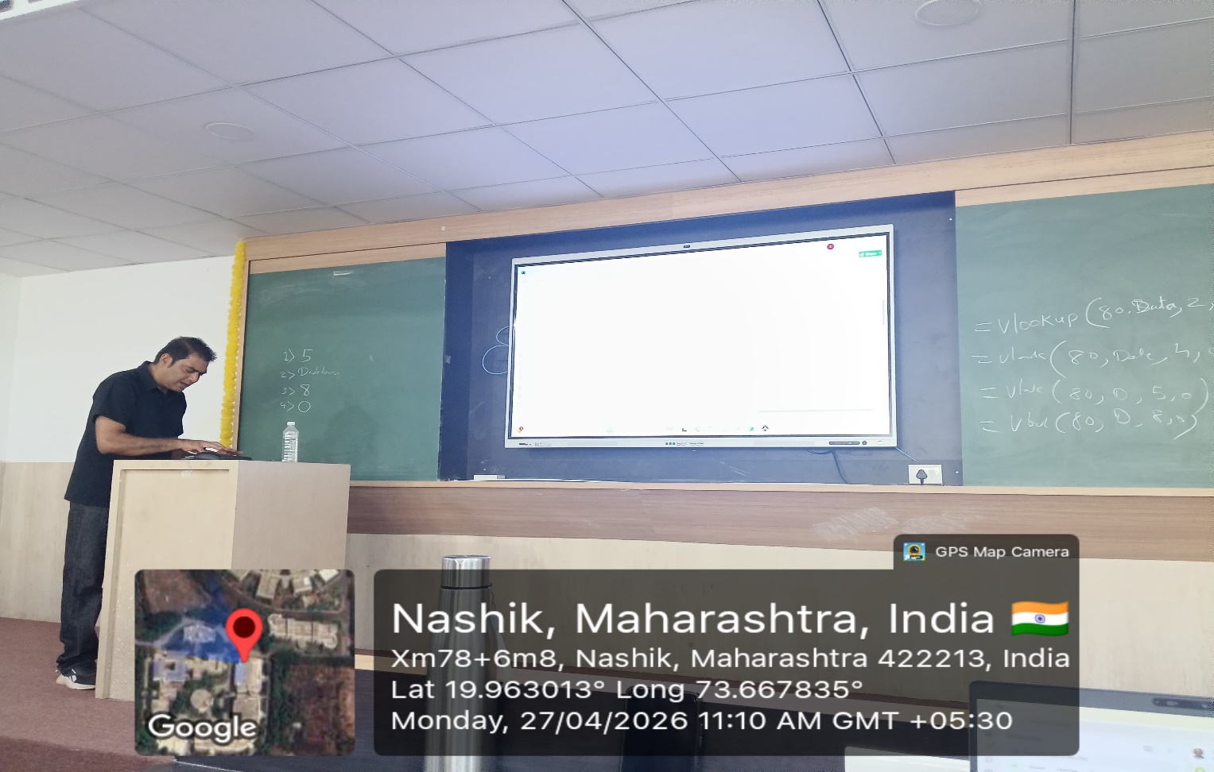
Photos:
