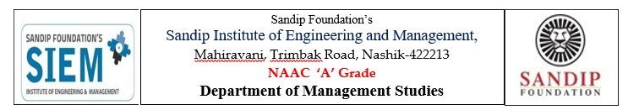
Institute Vision
We at SIEM aspire to be a globally recognized Institute that delivers a world class education to outstanding intellectual by nurturing and grooming by their interest, creative abilities and thrusts to acquire a life-long learning so as to imbibe values of their commitment towards society.
EVENT REPORT
Name of Event: Meditation: From Stress To Success
Date of Event: 25 April 2026
Resource Person: Mrs. Vaishali Vijay Patil
No of Participants: 50
Details of Participants: FY MBA & FY BBA Student
Coordinators of Event: Prof. Rohankumar V. Mishra

Objectives:
- Reduce stress and anxiety levels
- Improve concentration and focus
- Enhance emotional stability
- Promote mental clarity and positivity
- Support personal and professional success
What is Meditation?
Meditation is a mental practice that involves focusing the mind, calming thoughts, and achieving a state of relaxation and awareness. It helps individuals connect with their inner self and develop mindfulness. Regular meditation enables better control over emotions and reactions.

Causes of Stress
- Academic and work pressure
- Lack of time management
- Personal and financial issues
- Overuse of technology and social media
- Lack of proper rest and relaxation

Role of Meditation in Stress Reduction
Meditation helps in calming the mind and reducing negative thoughts. It lowers stress hormones and promotes relaxation. Techniques such as deep breathing, mindfulness meditation, and guided meditation help individuals stay present and avoid overthinking.

Meditation as a Path to Success
Meditation not only reduces stress but also contributes to success in various ways:
- Improved Focus: Enhances concentration and productivity
- Better Decision-Making: Promotes clarity of thought
- Emotional Balance: Helps in handling challenges calmly
- Increased Creativity: Encourages innovative thinking
- Self-Discipline: Builds consistency and patience

Benefits of Regular Meditation
- Reduces anxiety and depression
- Improves mental health
- Enhances memory and learning ability
- Promotes physical well-being
- Increases self-awareness and confidence

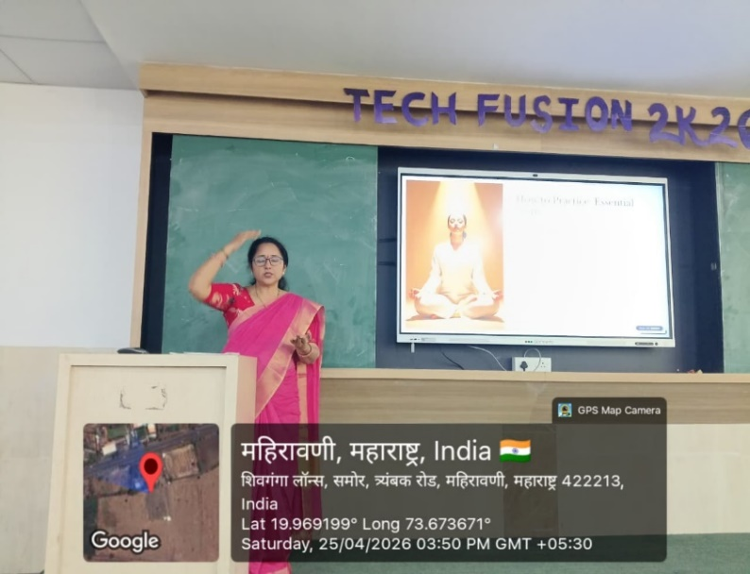
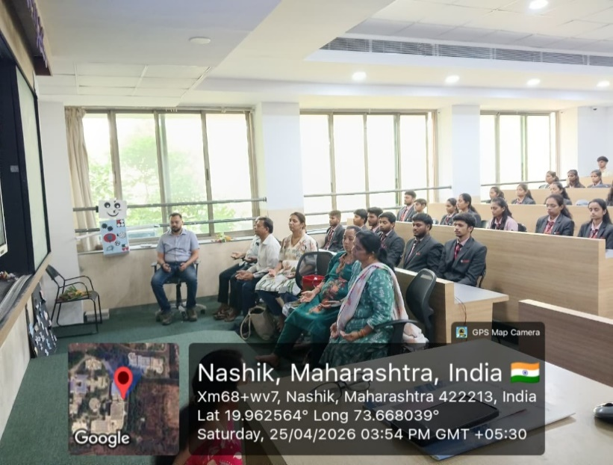
Photos :
