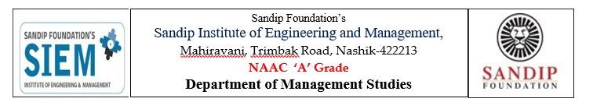
Institute Vision
We at SIEM aspire to be a globally recognized Institute that delivers a world class education to outstanding intellectual by nurturing and grooming by their interest, creative abilities and thrusts to acquire a life-long learning so as to imbibe values of their commitment towards society.
EVENT REPORT
Name of Event: Career Opportunities and allied skill
Date of Event: 11th April 2026
Resource Person: Mr.Nanasaheb Kolge
No of Participants: 50
Details of Participants: FY MBA & FY BBA Student
Coordinators of Event: Prof. Rohankumar V.Mishra

Objectives:
- To introduce students to various career opportunities available in different industries and professional domains.
- To develop awareness about allied skills such as communication, teamwork, leadership, and problem-solving required for career growth.
- To guide students in understanding current industry expectations, employability skills, and professional ethics.
- To motivate students to enhance their technical and interpersonal competencies for better career prospects and lifelong learning.

Outcomes of the Guest Lecture
- Students will be able to identify different career opportunities related to their field of study.
- Students will understand the importance of allied skills and their role in professional success.
- Students will gain knowledge about industry requirements, workplace behaviour, and employability skills.
- Students will be encouraged to improve their communication, analytical, and professional skills for career development.

Photos :
