   | Sandip Foundation’s  Sandip Institute of Engineering and Management,  Mahiravani, Trimbak Road, Nashik-422213  Phone: (02594) 222 581/82/83/84, Fax: (02594) 222 585  http://www.sandipfoundation.org / info@siem.org.in  ======================================================= |   
TECH-FIGHT 2K26

- Event Title: Tech-Fight 2K26

- Event Date: 02nd April, 2026

- Event Duration: 10:00 AM to 05:00 PM

- Event Venue: Computer Engineering Department, SIEM, Nashik

- Event Coordinator(s): Event Coordinator Prof. Vijay A. Sonawane, Staff Co-coordinators Dr. P. V. Baviskar, Dr. Ompal Singh, Prof. Suhas Nagori, Prof. Vina Warade, Prof. Pratima Pawar, Student Members of C.E.S.A., Student Coordinators and Volunteers (SE and TE)

- Expected Audience: Honorable Chief Guests, Respected Principal Sir, HOD’s, Faculty members of Computer Department, Students and other college students.
- Total No. of Participants: 418

- Event Objectives & Outcomes:
  - To give a platform to our young budding engineers for showcasing their innovative ideas and creating a competitive atmosphere for the holistic development of students.
  - Create an opportunity for students to enhance their leadership and organizational skills.
  - To imbibe the culture of multi-institute competition among students
  - To facilitate Student Industry interaction
  - To provide an occasion of department students to nurture their Management skills and leadership.
  - Outcome: - The event simply received an overwhelming response from the participants and was a huge success.

  - We, the department Computer Engineering, organized technical event TECH-Fight– 2K26 with different competition such as Project Competition, Prompt Engineering, Hack_in_60.
  - Futsal, Treasure Hunt, E-Waste for diploma and degree students. The purpose of organizing this event is to motivate the students for presenting the contents and scope of work effectively and to develop illustrative skills, graphic skills, Social awareness & creativity in students.

- Event Photographs:

PUBLICITY POSTER

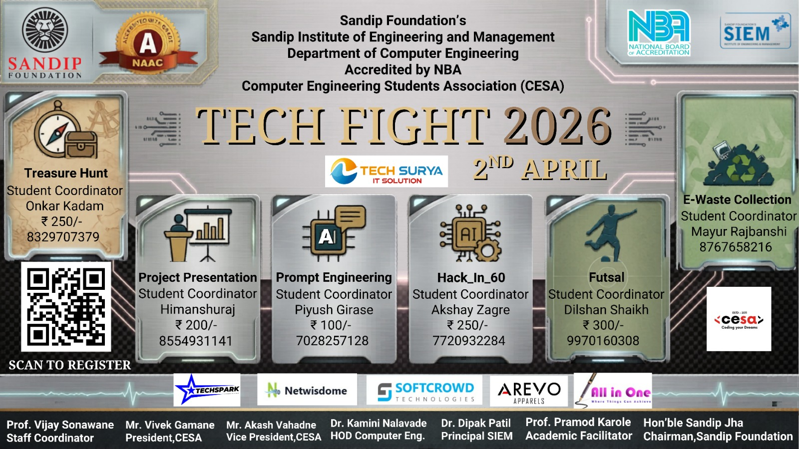
TECHFEST INAUGRATION CEREMEONY

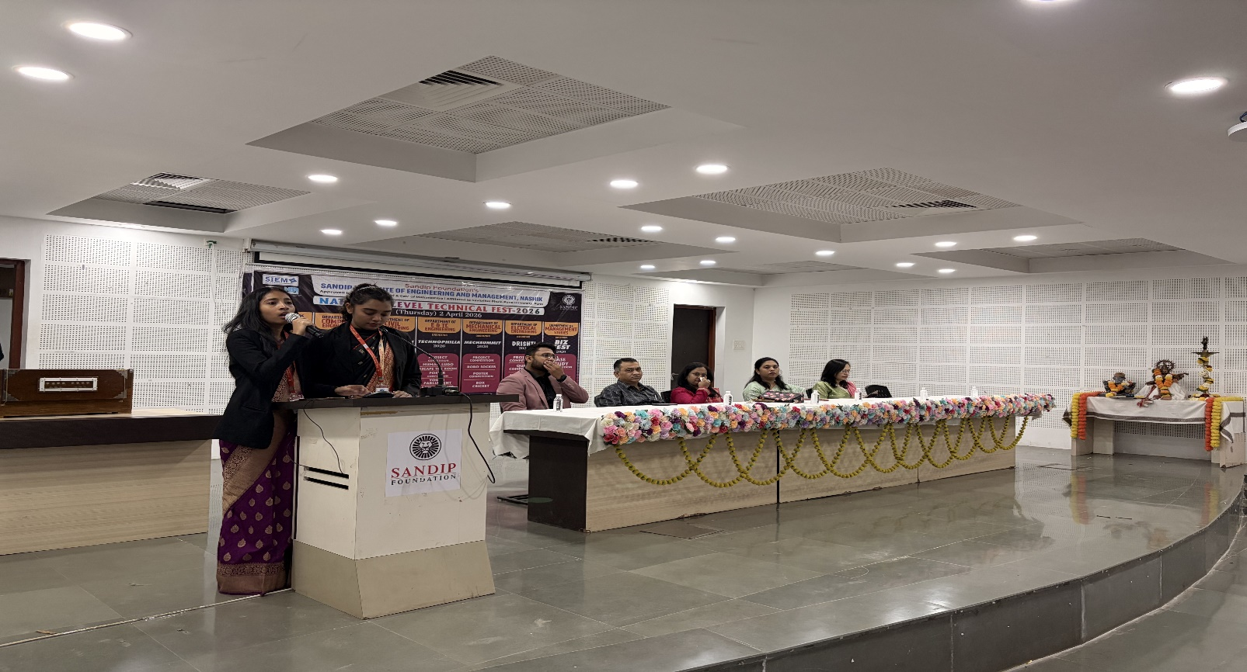

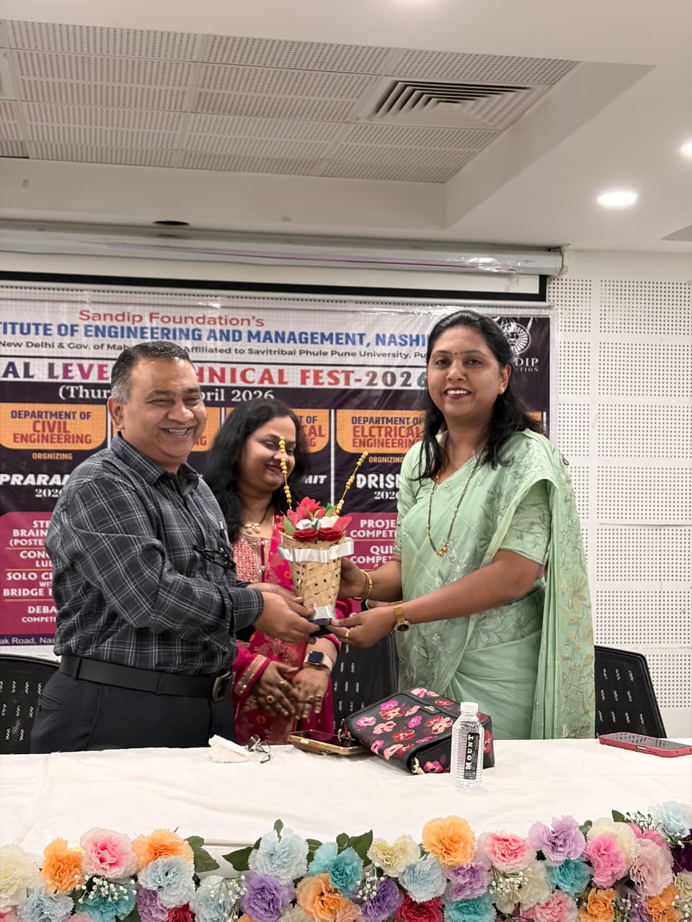
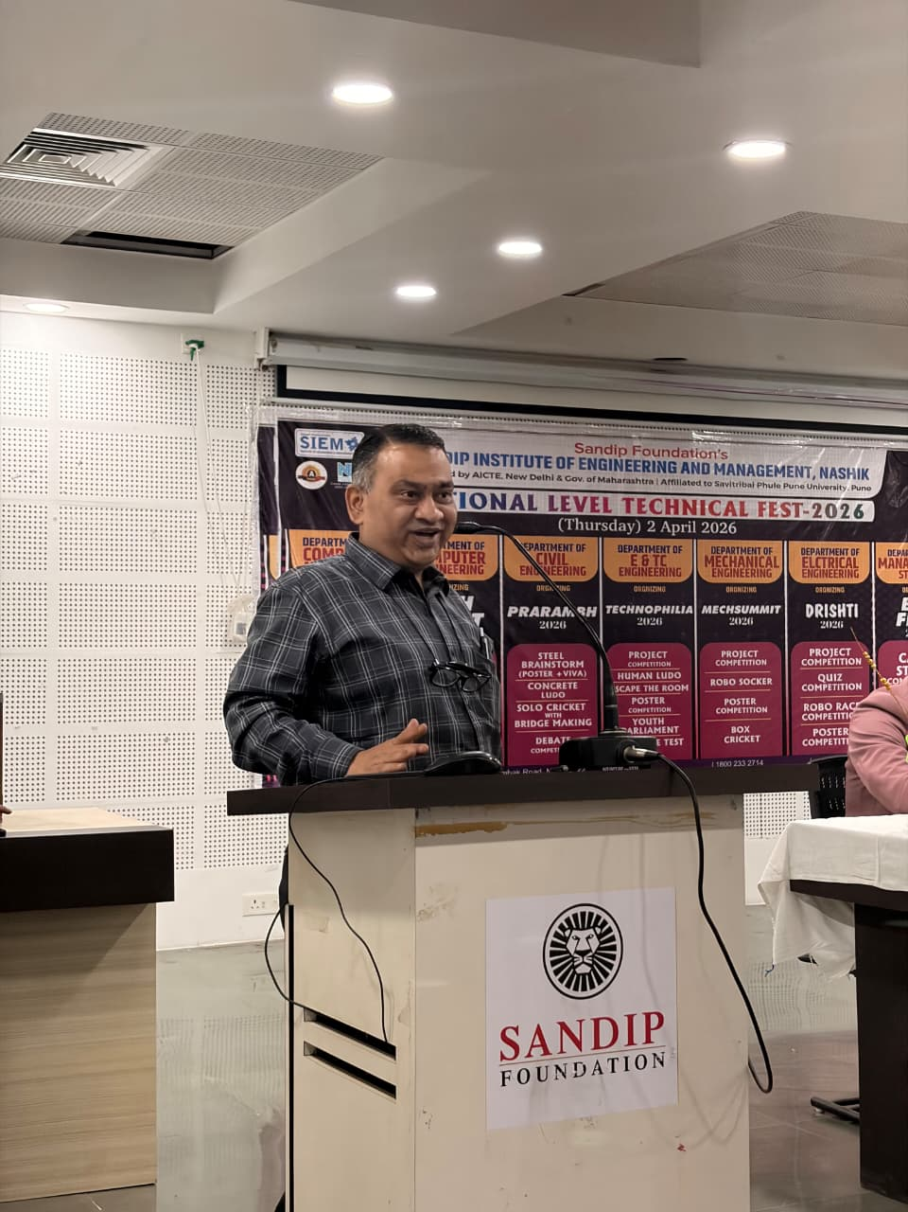

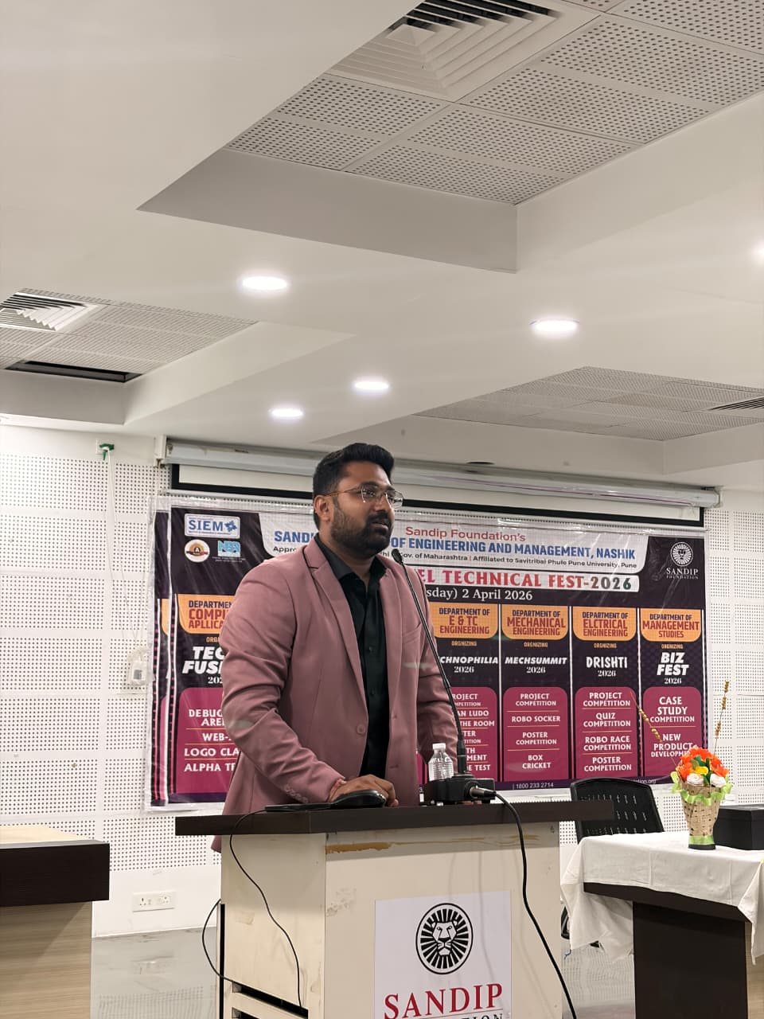

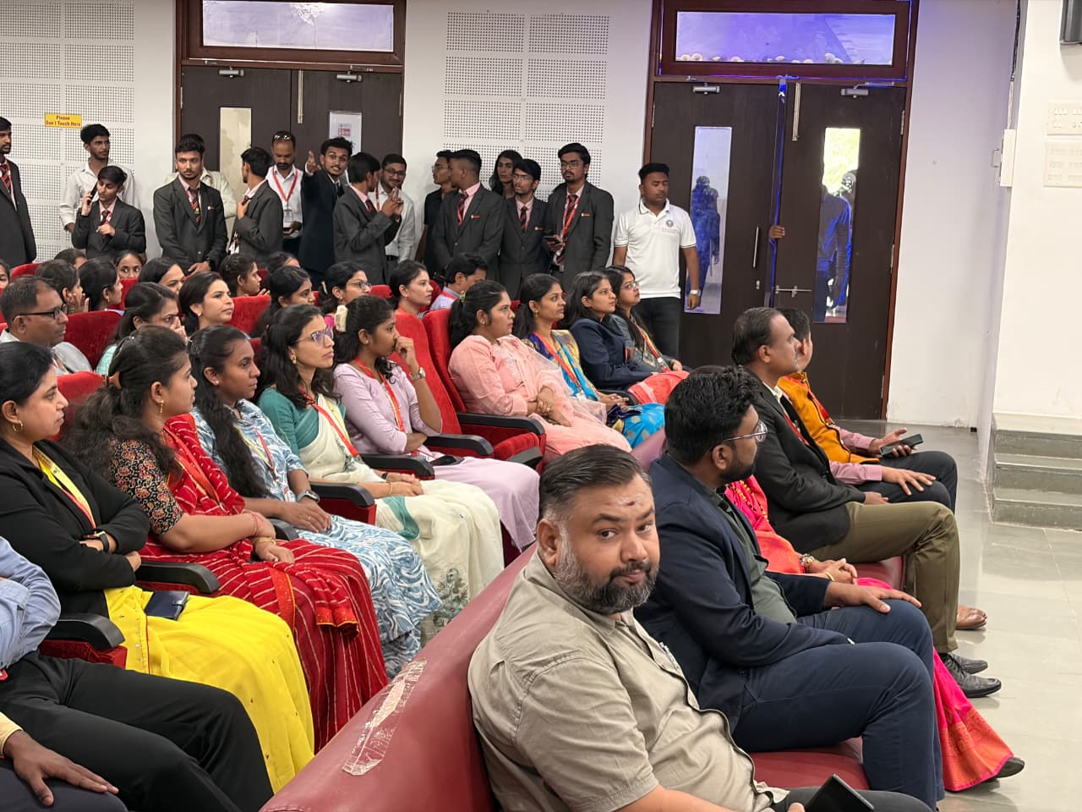

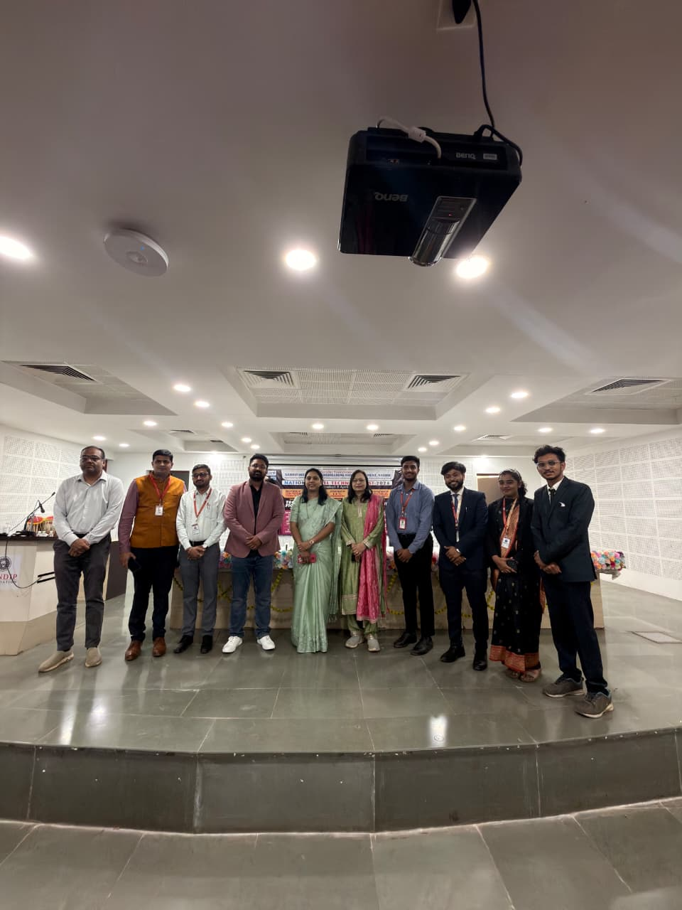
PROJECT COMPETITION EVENT

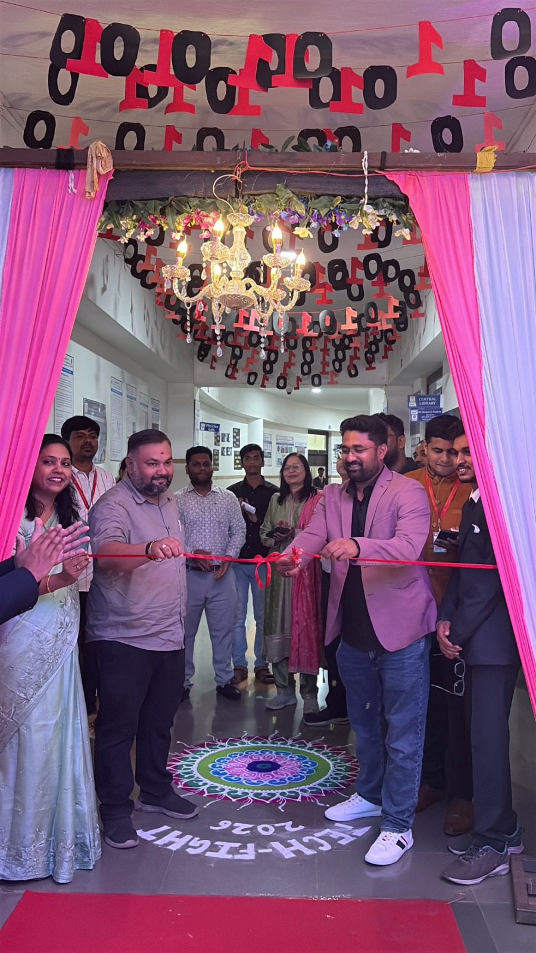

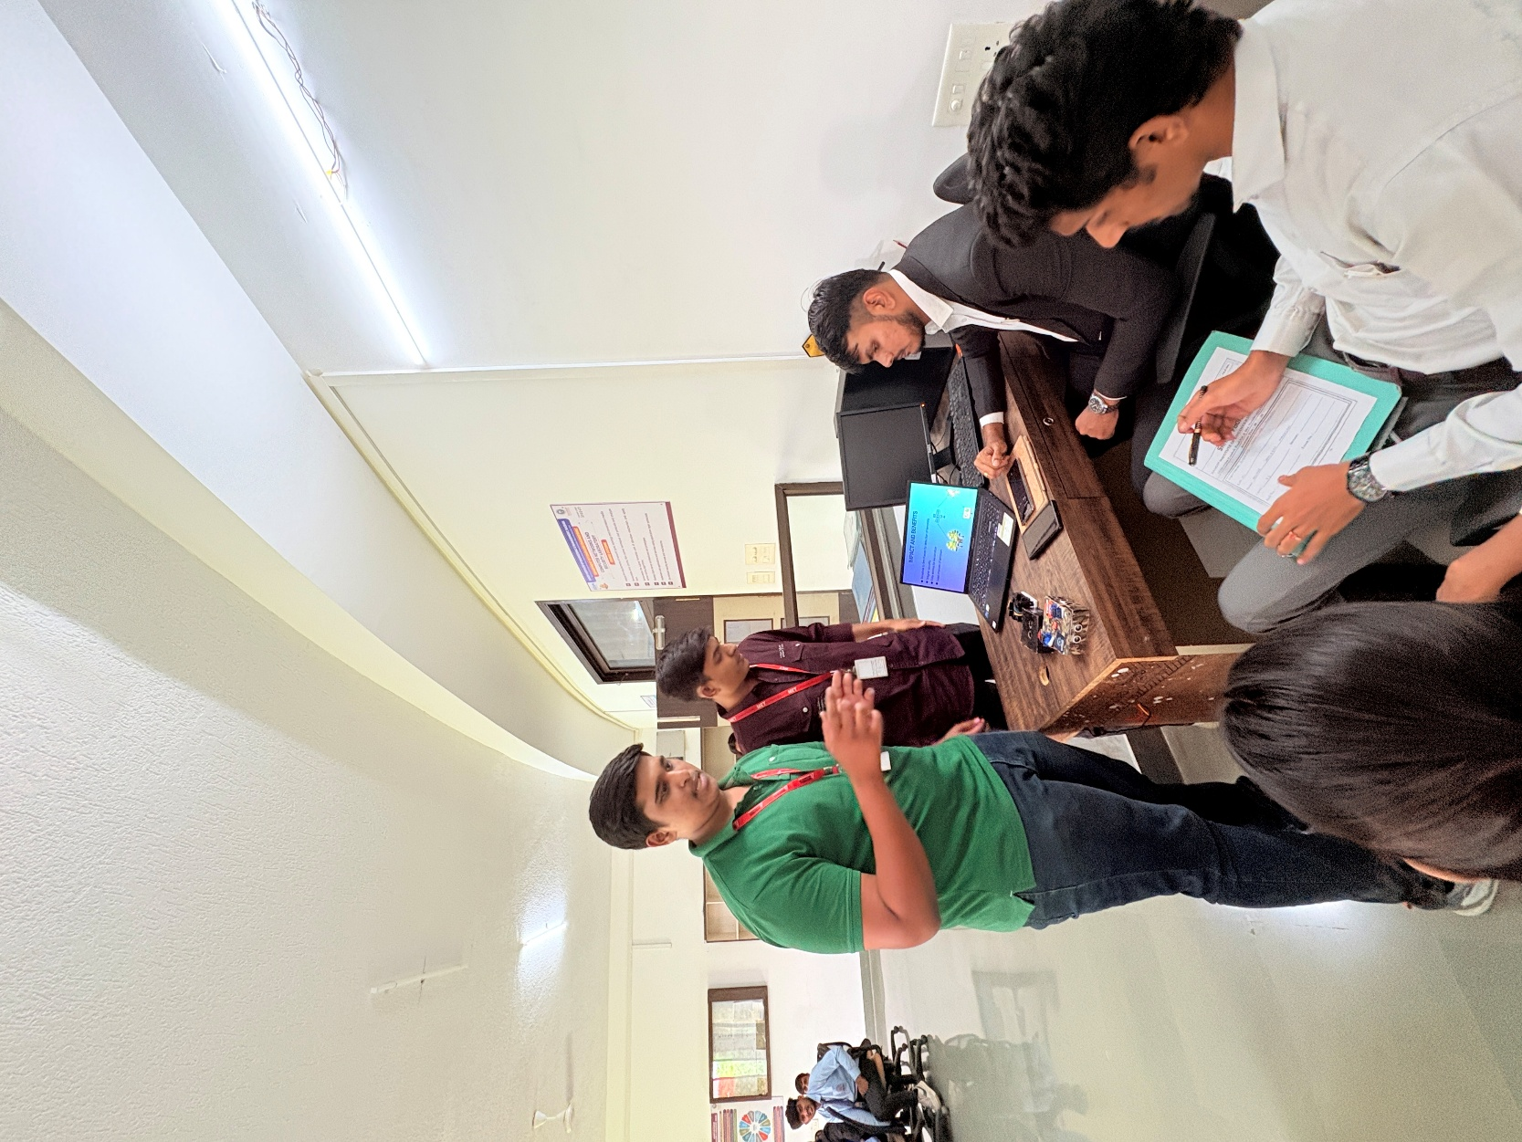

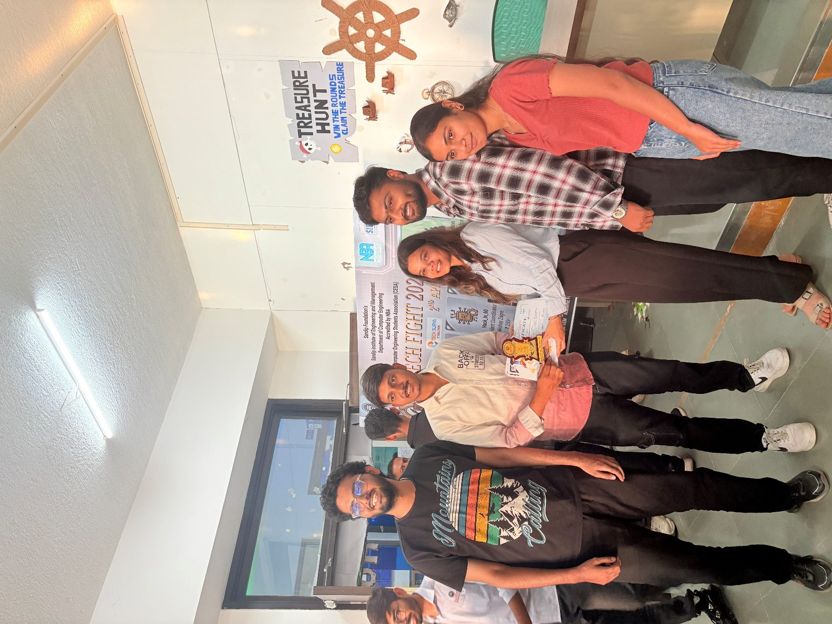

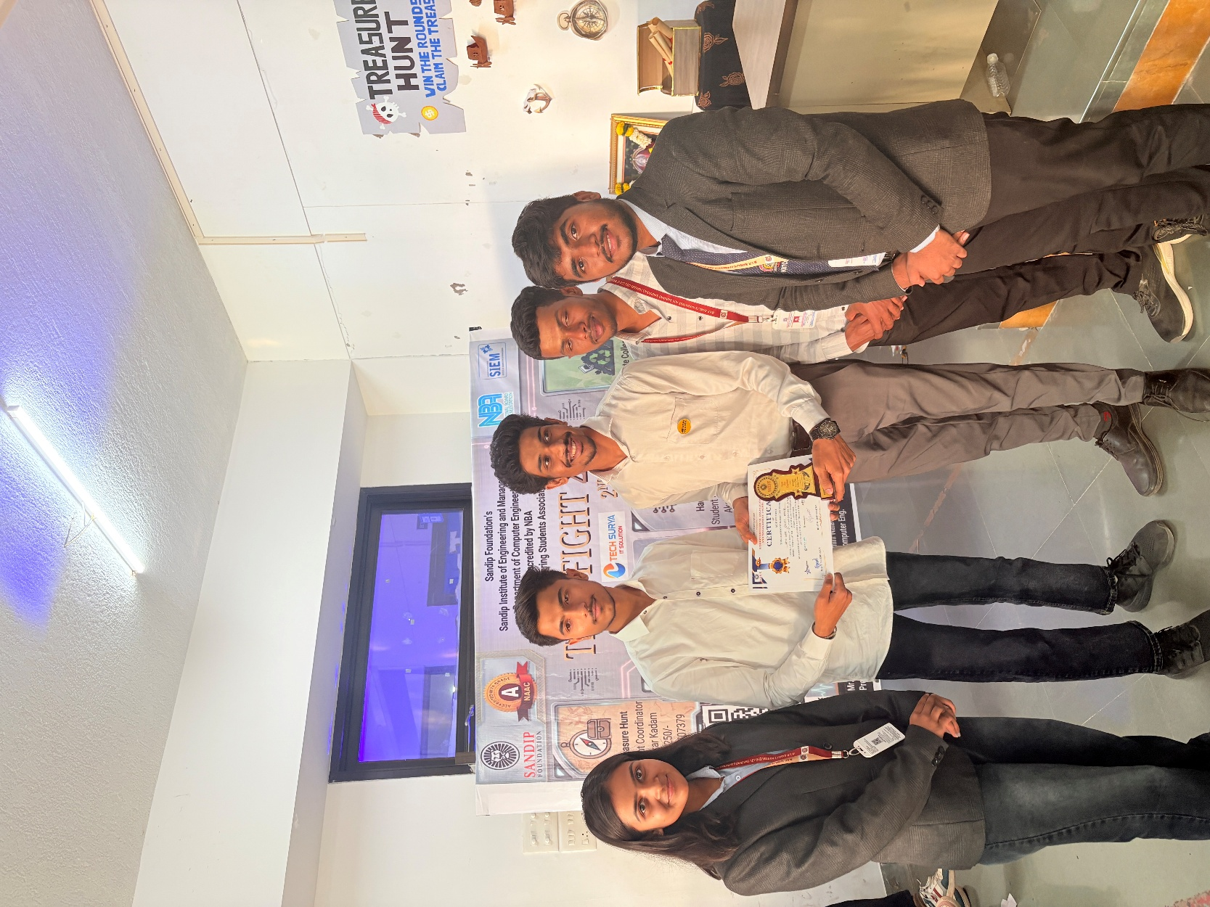

HACK_IN_60

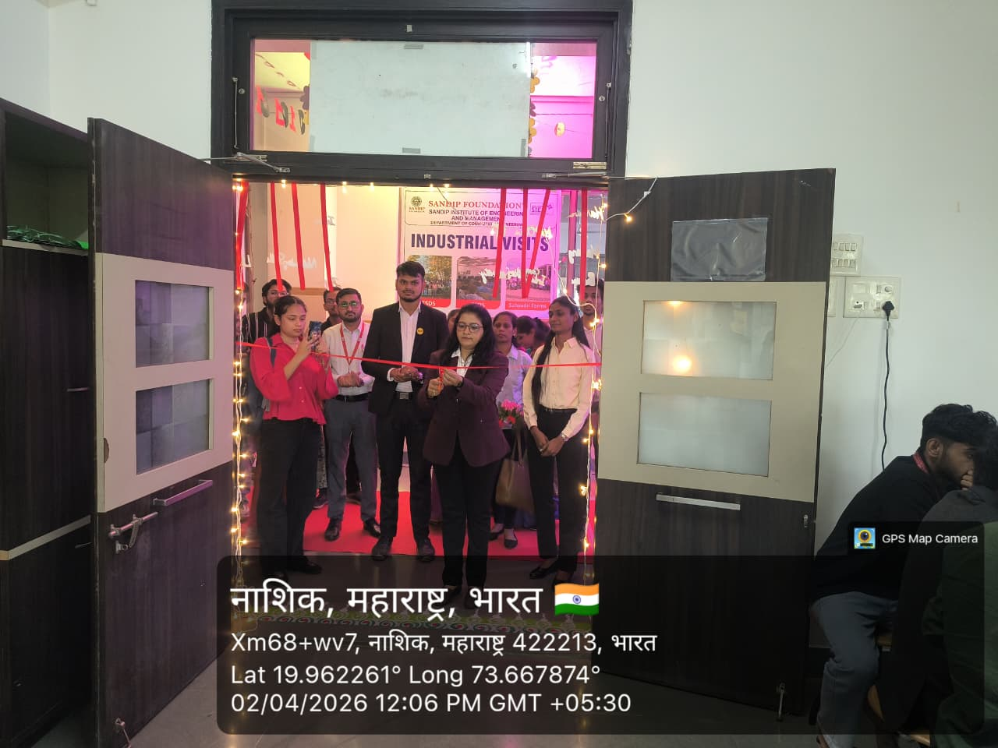

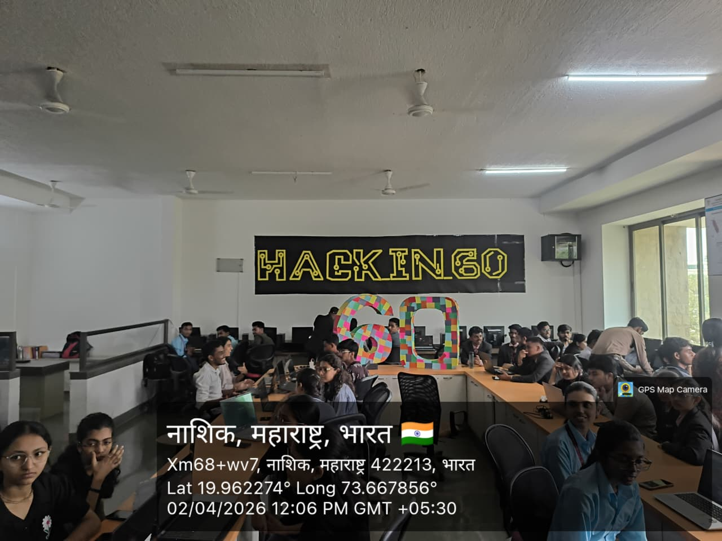

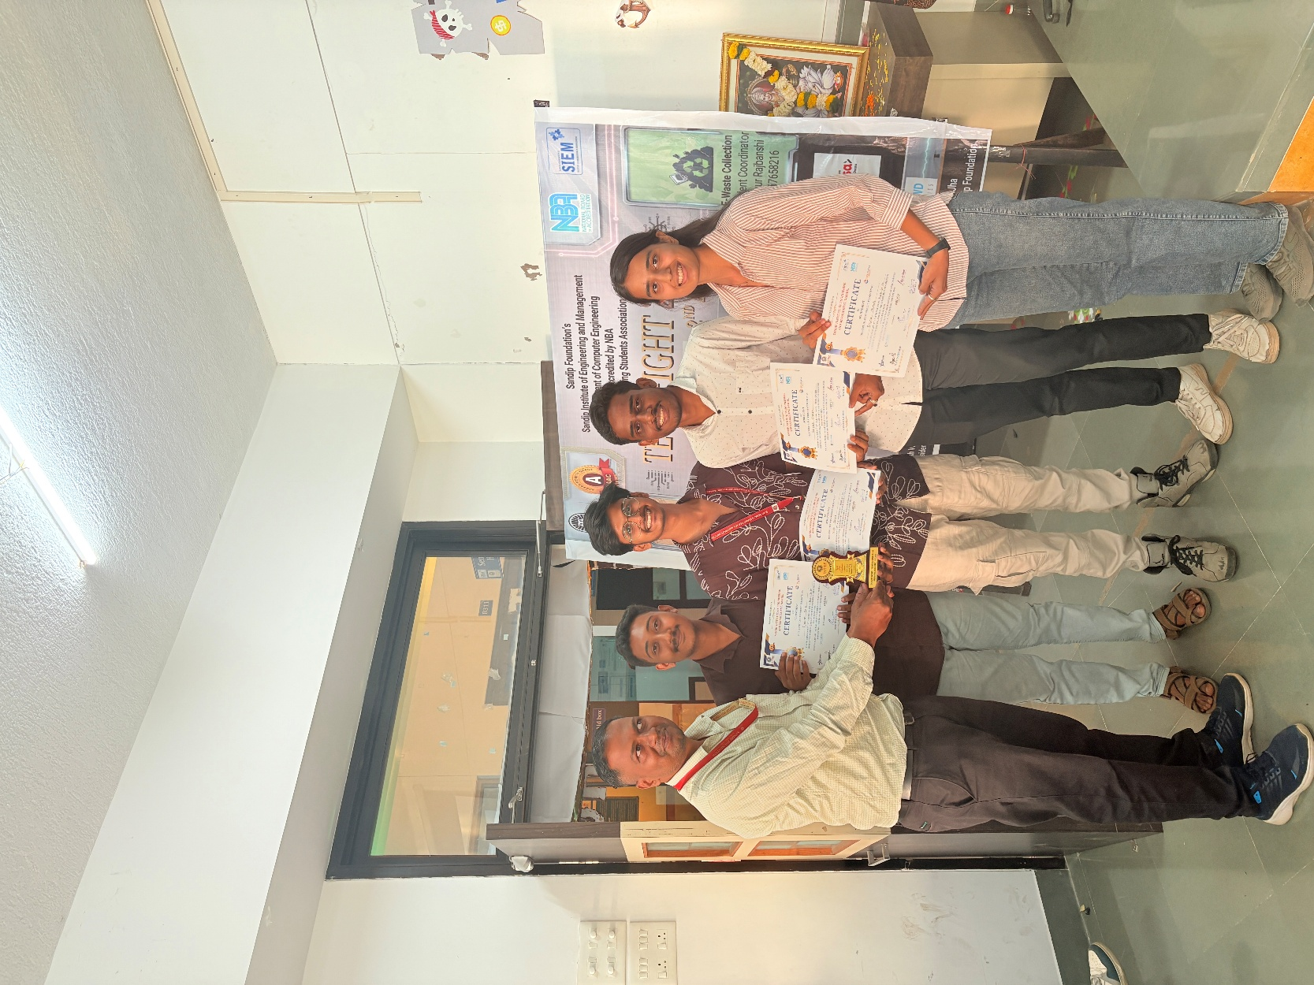
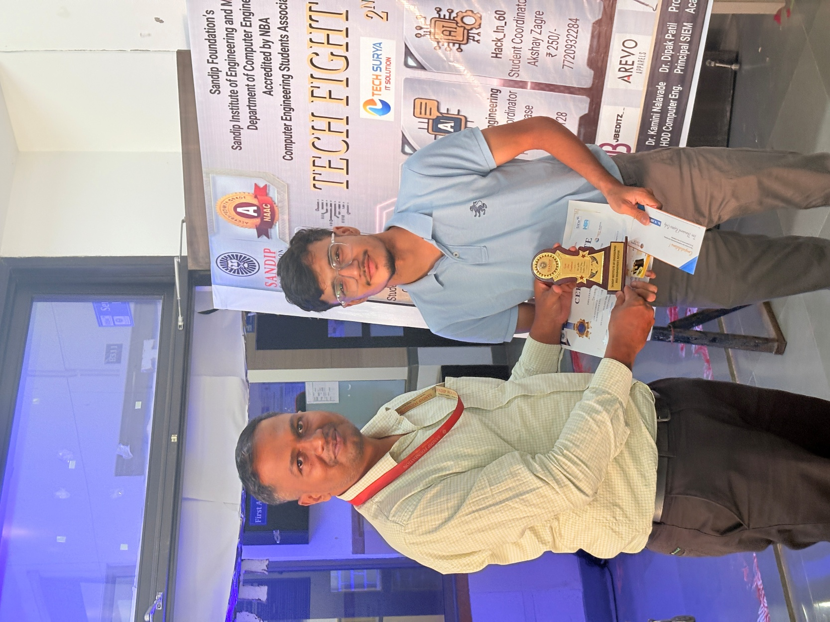

PROMPT ENGINEERING

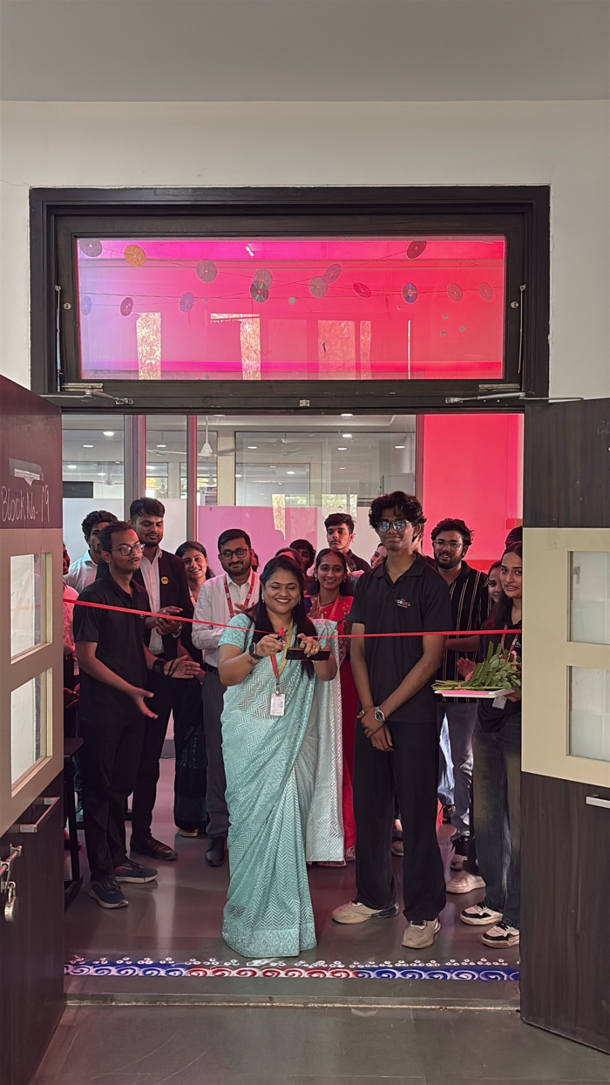

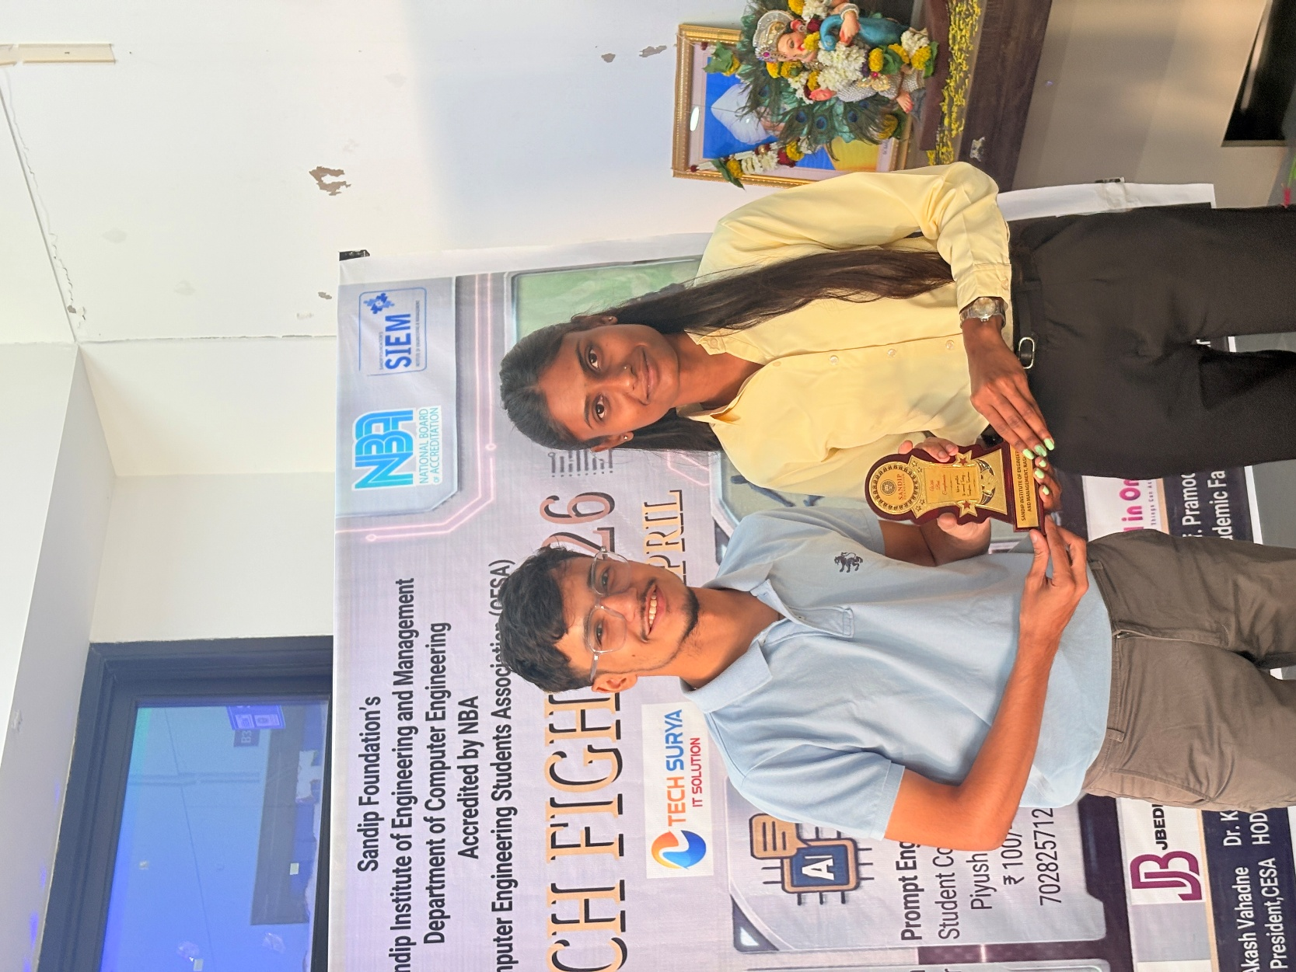

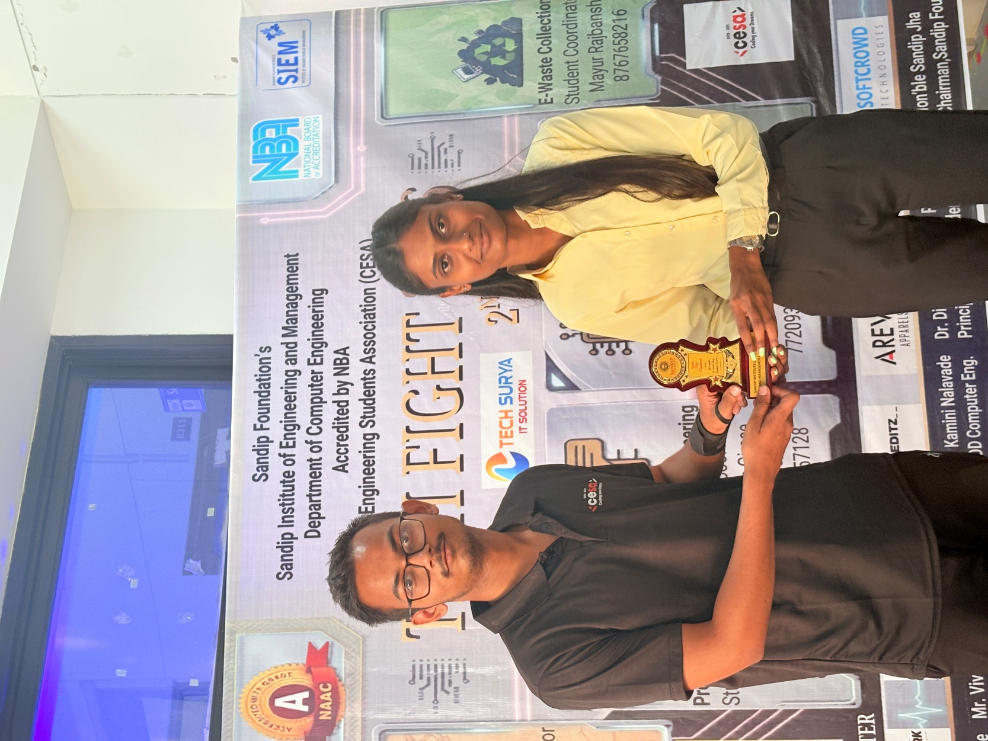
FUTSAL

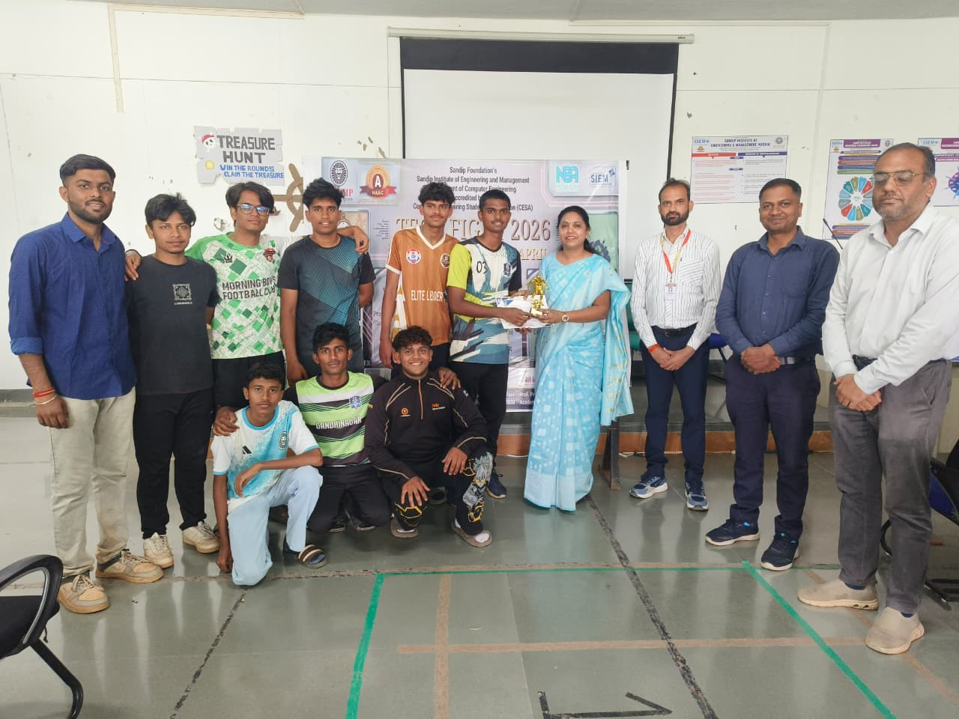

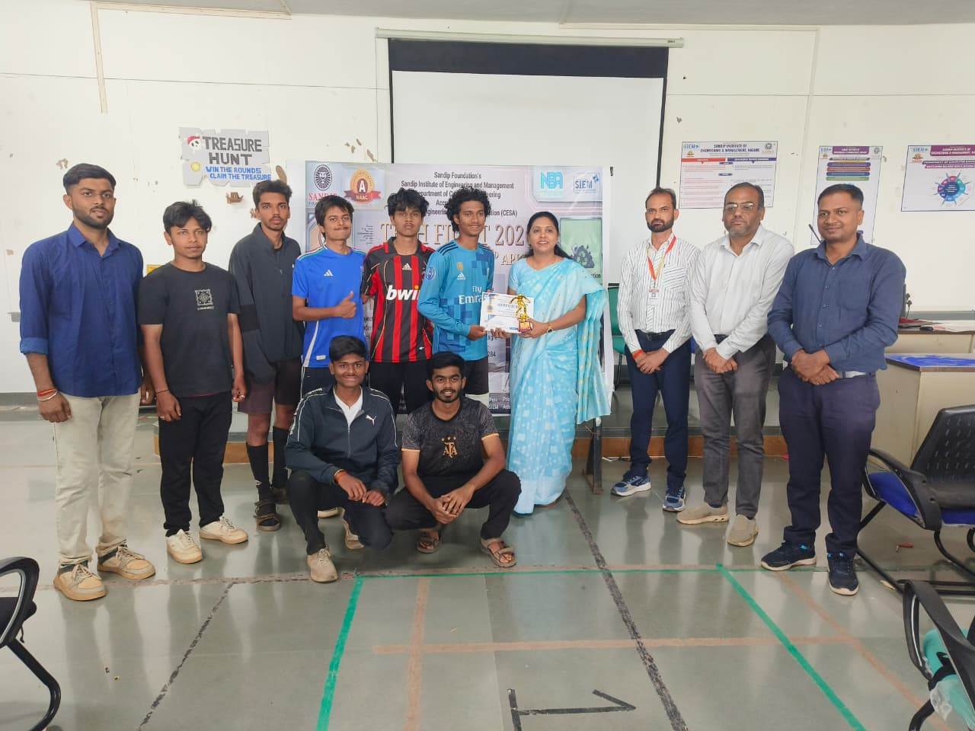

TREASURE HUNT

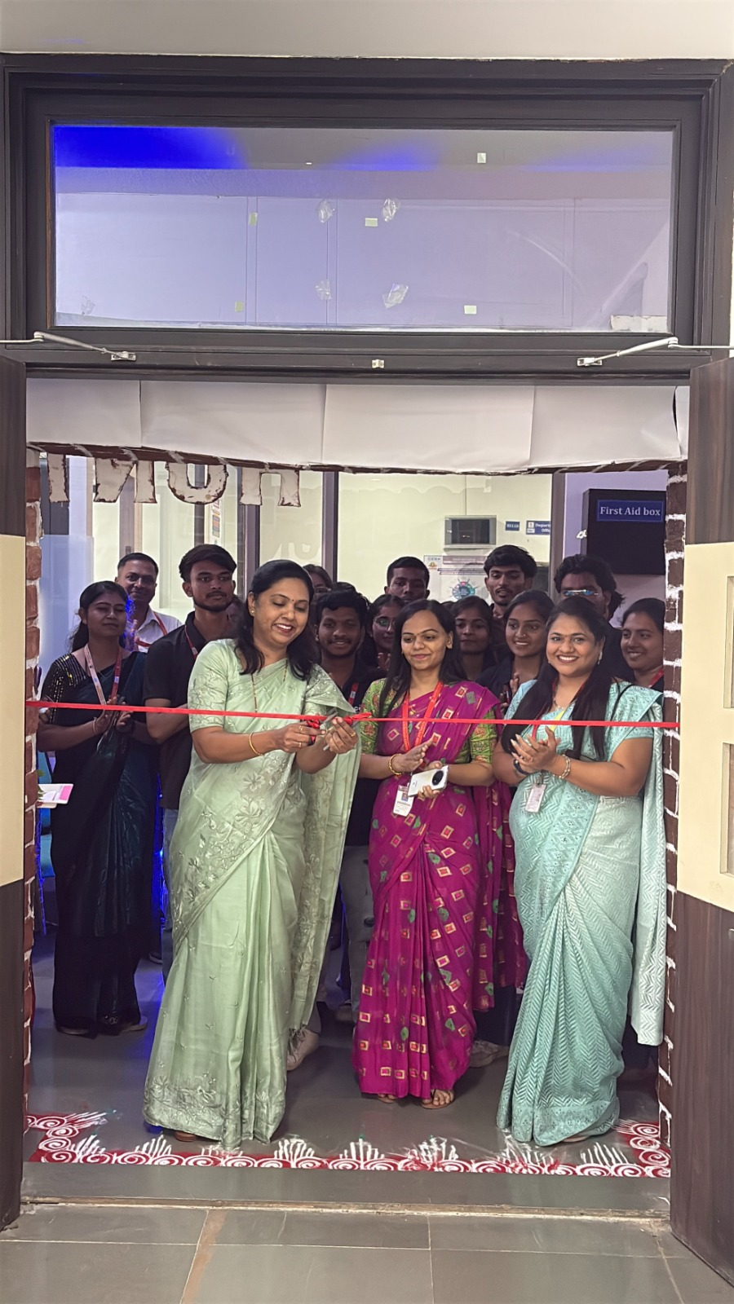
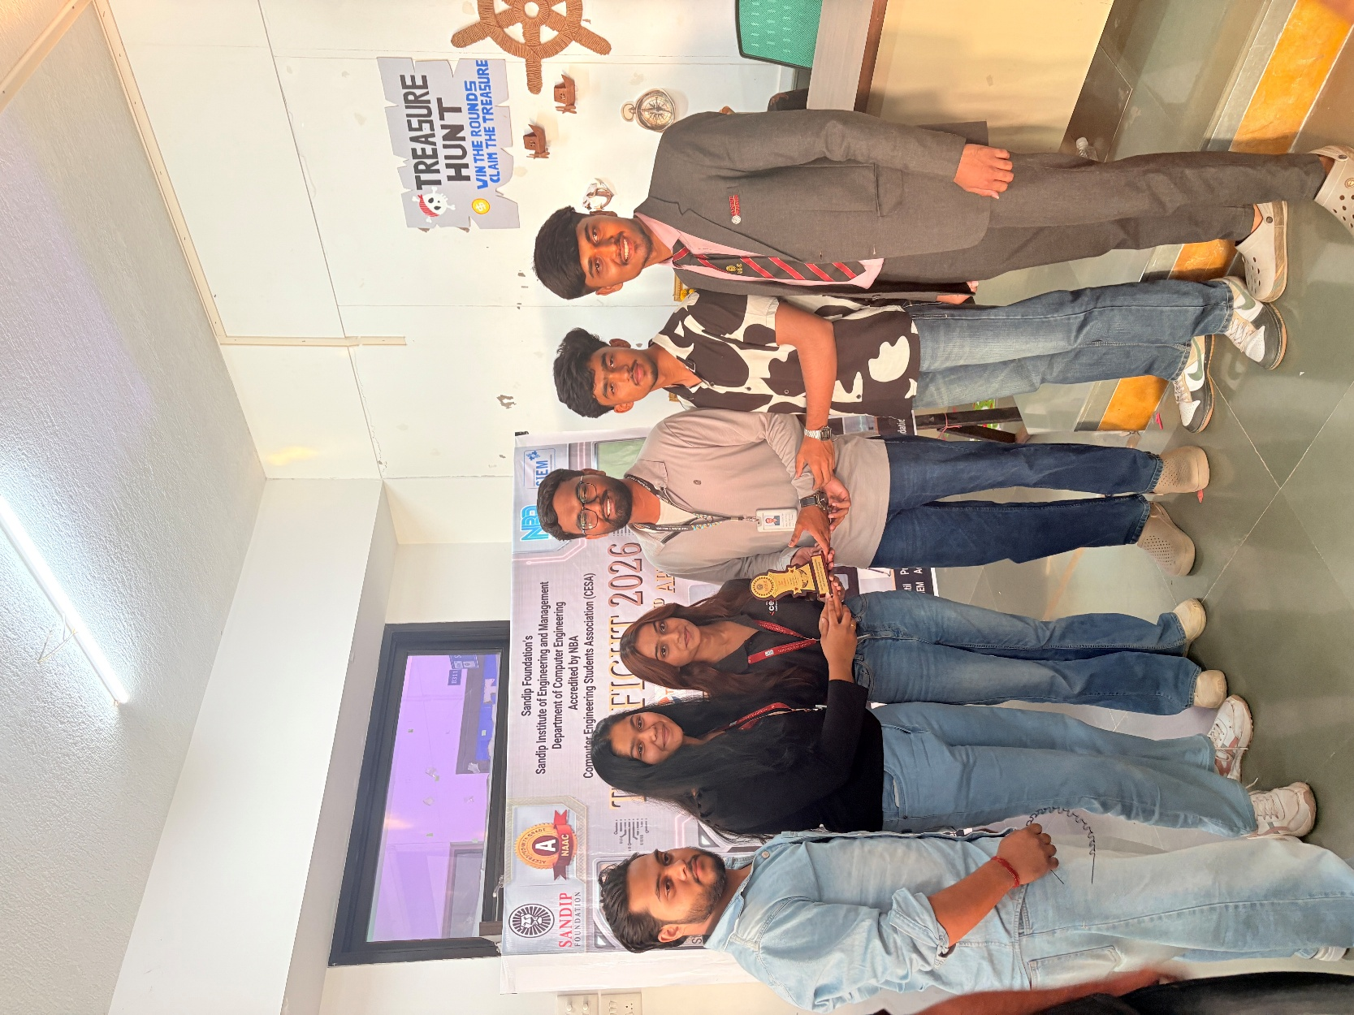

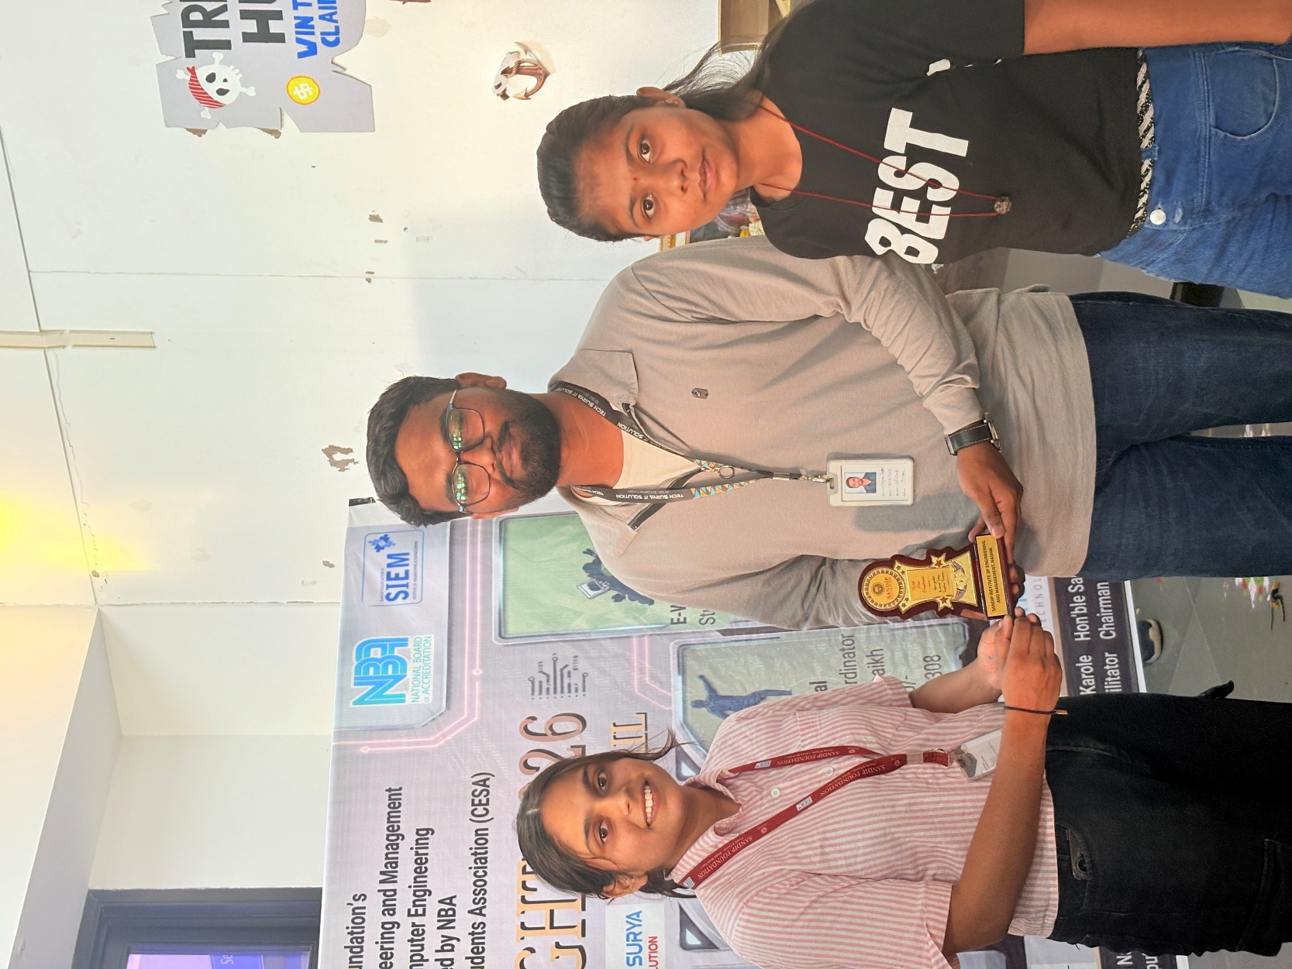

- Winners Details:

Sr. No. | Event Name | Name of winner | Rank
1 | PROJECT  COMPETITION | Hamiz and Team for Episcan | 1st
1 | PROJECT  COMPETITION | Rohit and Team for Kumbhpath | 2nd
2 | Hack_IN_60 | Kalpesh Chavan And Group | 1st
2 | Hack_IN_60 | Devang Bhattad | 2nd
3 | Prompt Engineering | Devang Bhattad | 1st
3 | Prompt Engineering | Shivam Shirsath | 2nd
4 | Treasure Hunt |  | 1st
4 | Treasure Hunt |  | 2nd
5 | Futsal | Gandhinagar FC | 1st
5 | Futsal | MFC | 2nd

